Real Estate Marketing Content for Generation Z
Names
Institutional Affiliations
Introduction
Over the past decade, the real estate industry has gone through interesting ups and downs. However, after the 2012 rock bottom the industry has had a steady and rapid increase in membership as competition among realtors keeps on heating up. However, most of the marketing operations carried out by players in the industry are the traditional ones. There is also a growing competition in the industry over the emerging Generation Z customers. Everyone is now talking about the things that will make Generation Z tick and the how the real estate industry will market to them. It is now time for the real estate industry to begin focusing on Generation Z, which refers to individuals born between 1995 and 2010. These are potential home buyers that expect content that is customized and digital interactions. Therefore, it is important to provide them with realistic home options where they are. Although the millennials and Gen Z might seem a bit similar, a closer look at the two generations displays their subtle differences, and these differences should be fundamental to real estate marketers. In this paper, I will discuss the strategies for creating quick and effective online content and how they can help the real estate industry in marketing their products to the members of Generation Z.
Creating Quick and Effective Content to Market to Generation Z in the Real Estate Industry
The demographic of the individuals born between 1995 to the mid-2000s accounts of about 32% of the world’s population. These individuals are digitally savvy since they were brought up with iPads and mobile phones and they are not aware of any time where the internet did not exist. Real estate marketers can only grab their attention in a short span of time of around eight seconds failure to which they be forgotten forever. As the real estate agents are still in the process of buying homes, Generation Z have begun conducting more leg work online before engaging the experts. There is a need for real estate agents to have an active online presence because potential Generation Z home buyers use the internet in their quest for hunting houses. Therefore, it is now important to actively engage and network online. The following strategies can be used in the creation of effective content to market real estate to Generation Z.
Establishing trust through transparency
Individuals are unique in their own way regardless of their generation. Nevertheless, there are some assumptions about the world, which differentiate people with regards to age. Reflective of a population that is the most diverse ethnically, people in Generation Z appear to be more inclusive than the previous generations (Chuang, 2020). They have developed an acute sense of differentiating fake things from genuine while coping with daily bombardment of ad messages due to the fact that in their entire lives they have been target-marketed. Consequently, this is a generation that values honesty and transparency. While creating quick and effective content to market properties to Generation Z therefore requires providing a proper explanation of what is happening and why since it helps in establishing trust and loyalty, and most especially when revealing confidential details. In addition, a young home buyer seems to see less need for formality, and most particularly with individuals that are older in authority. Generation Z is more contend with a flattened hierarchy where everybody is treated in a friendly manner. The contentment can be of interest and most especially to real estate brokers since they take into account communication styles with these agents that are new and younger (Artemova, 2018).
Crafting the appropriate message
Based on the fact that the Generation Z interacts socially and consumes information basically via the use of mobile devices, this has completely altered the manner in which real estate companies should market their products to this audience. With respect to the Mobile Marketing watch, averagely, texts command 98% of open rate when compared to a 20% average email open rate. Again, according to SlickText, which is a text messaging marketing firm, the average individual reads a text message within 5 minutes after receiving it and replies to it within 901 seconds when compared to the 90 minutes that it takes for one to reply an email. Consequently, there is a need for players in the real estate industry to make use of the dotloop text messenger tool when passing advertising messages to Generation Z. Moreover, in order to provide real estate agents with full mobile freedom for complete transactions in every place that they go, dotloop messenger can provide agents and administrators with the ability to move the transaction forward faster through offering clients with the kind of communication that they prefer and thereby enhance the client response times. Notably, the Generation Zers spend most of their time in what is known as alternating attention (Anjum, Thomas, & Prakash, 2020). Within few minutes, individuals in this generation alternate from one social media platform to another, hoping between subjects, circles of social media platforms and relationships. Additionally, when it comes to their consumption of streaming entertainment like Netflix, they normally have their smart phones out, jumping quickly between the two screens. Therefore, the marketing content should get to the point faster, must not talk down to the audience, and acknowledge Generation Zers fast pace of life better than what was being done by previous marketing generations (Du, 2017). Simultaneously, Generation Z needs to be provided with information about how to become successful in life. This is due to the fact that they are most probably entering work life around the bottom rung and have already started on a steep career learning curve. A real estate agent that can assist them in achieving the seemingly difficulty milestone of ownership will be regarded by this generation as a luminary connection.
Figure 1: Netflix and YouTube ad revenues
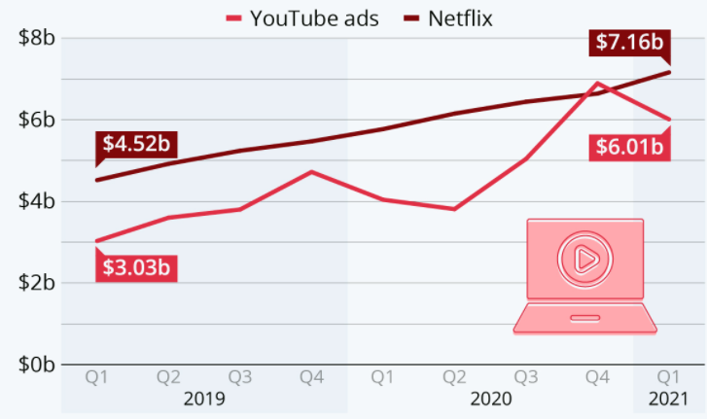
Choosing the right channels
The medium is the message and in the same manner, the channels that are most favored by Generation Z determiner the type of posts that will be most effective. Notably, Generation Z is moving away from Facebook, which they regard as a grandmother social media platform, and they are now in other more advanced platforms such as YouTube, Snapchat, Tiktok, and Instagram. In addition, younger women in this generation are heavily present in Pinterest while their male counterparts are in Reddit. In accordance with Hootsuite, YouTube is the most popular platform for Generation Z as they turn into the platform 24% in search of recommendations for shopping, followed by Instagram at 17%, and Facebook 16%. The manner in which these social media platforms are consumed is focused mainly on brevity. A limited number of the characters that are displayed on the screen and also a limited screen size have conditioned this generation in way that that they absorb marketing content in small bites, meaningless text, shorter videos, and a lot of images (Hang, Foo, Kang, & Wong, 2018). Remarkably, real estate marketers will only have 8 seconds to grab the attention of Generation Z before they can skip the ad. It is important for marketers in the real estate industry to take into account the fact that this is a tech-savvy generation and is skilled at looking at a post and in a fraction of a second making a decision in any way that is relevant to them. As opposed to the other previous generations, a Generation Z customer consumers technological tools to narrate the real estate story. These tools include but not limited to virtual reality, live video, and the 360 video property views (Jaakonmäki, Müller, & Vom, 2017). Furthermore, real estate agents that are tasked with the mandate of conveying their property selling proposition with images that intrigue, engaging videos, and brief messages that have immediate takeaway will cultivate more with Generation Z.
Figure 2: Most popular consumer brands on YouTube
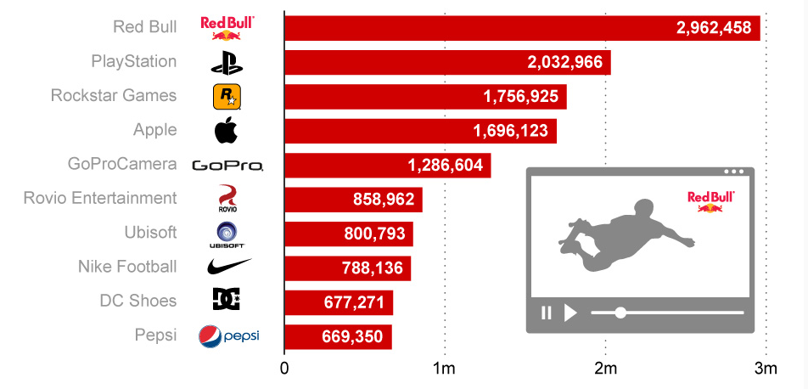
Consistent delivery
It is important to ensure that real estate marketing messages are delivered with consistency in the pursuit of connecting with any demographic. Nevertheless, it is particularly true for reaching out to Generation Z customers that receive almost all their marketing messages through the small screen. For instance, 85% of Generation Z get to know about new products in the market on social media platforms such as YouTube and Instagram and are have a high likelihood than the previous generations to connect with brands on these platforms. Consequently, in order to connect with this generation in a platform where they feel that they are most comfortable, it is important for real estate agents to utilize social media platforms consistently. This simply implies that there should be a consistent message, look, and posting schedule. Just like taking care of a garden, tending the presence on social media should be a long term commitment. In addition, it is important to consider a particular group of interest known as influencers due to the fact that they have a high probability of grabbing both the minds and hearts of Generation Z. strikingly, influencers refer to interesting individuals that share their life aspects repetitively on social media. Typically, these influencers talk directly and in an informal manner to their audience. This content is loved by Generation Z for authenticity purposes. Therefore, real estate agents should not share canned content when dealing with this generation since it will seem insincere and fake to them.
Being Ready to Respond
Generation Z members do not care about the number of influencers and followers that they have on social media. Remarkably, with regards to Markerly an influencer marketing network firm, nano-influencers that have between 1000 and 5000 followers have more than four times the engagement rate as influencers that have over 10000 followers. Based on the fact that nano-influencers have a small number of followers on social media platforms, they still feel like every day people to fans. Consequently, these nano-influencers have a high probability of establishing engagement relationships with their followers. It is this type of engagement that keep fans hooked. Therefore, since the typical Generation Z can be directed about their privacy issues with regards to mass marketing, these customers are also after personal interactions. When a young individual of 25 years reaches out to a real estate agent through a private message on Instagram, the agent should provide a quick response and ensure that he/she does not abuse that connection with spam content (Ki, Cuevas, Chong, & Lim, 2020). In accordance with Hootsuite, both direct and private channels are effective with Generation Z to the extent that Facebook has decided to spinoff a standalone messaging app on Instagram known as Direct (Ying, 2020).
Figure 3: Social Media Audit for Chipotle
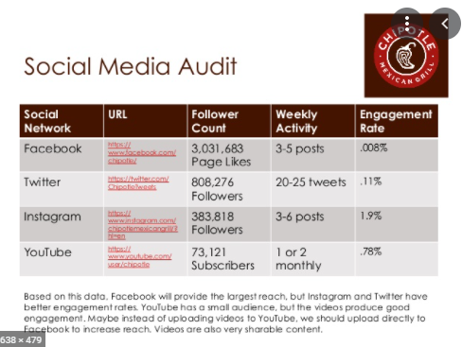
Video Content
Video content is very important when dealing with Generation Z. The first social media platform that this generation turns to when they need to get cheered up or entertained is YouTube. However, this is the only purpose that they utilize YouTube for as they still use the platform to enhance or gain new skills and also expand their knowledge. Therefore, YouTube is the perfect place where real estate marketers hook Generation Z but is crucial for them to come up with the right content (Korombel, & Ławińska, 2019). For instance, Red Bull with over 8 million YouTube subscribers has several playlists such as a popular series known as Red Bull Travel Vlogs. In partnership with Vloggers, Red Bull posts regularly lifestyle videos that are active with things such as skydiving and base jumping. It is through these videos that the company promotes the sale of its energy drink.
Figure 4: Picture of a Red Bull advert on social media

Similarly, real estate companies can employ the same technique on YouTube and Instagram to boost the sales of their products.

Conclusion
Due to the emerging competition in the real estate industry for the Generation Z clients, players in the industry will need to have a fast and effective online content to gain competitive advantage. The Generation Z members are individuals that have grown up with the internet and mobile phones at their disposal and therefore reaching out to them will majorly require digital content. First and foremost, real estate companies will have to establish trust with Generation Z through transparency as this is a generation that highly values honest and transparent dealings. In addition, it will be important to come up with the right message that is short and precise because this generation does not have much time to go through huge loads of information since they have a lot before them. Notably, it will be important to choose the right channel to deliver marketing messages to this generation. For instance, YouTube and Instagram are the perfect platforms where members of Generation Z can be hooked by real estate agents since they turn to these channels for entertainment and gaining extra knowledge. Again, real estate agents need to be ready to respond to social media messages and concerns raised by this generation as they like the engagement. In conclusion, in order to attract Generation Z clients, real estate agents need to change of traditional marketing methods and focus on the digital methods that I have discussed above.

References
Anjum, A., Thomas, M. R., & Prakash, P. K. (2020). Digital marketing strategies: Effectiveness on generation Z. SCMS Journal of Indian Management, 17(2), 54-69.
Artemova, A. (2018). Engaging Generation Z Through Social Media Marketing Case: Hurja Media Oy.
Chuang, S. H. (2020). Co-creating social media agility to build strong customer-firm relationships. Industrial Marketing Management, 84, 202-211.
Du Plessis, C. (2017). The role of content marketing in social media content communities. South African Journal of Information Management, 19(1), 1-7.
Lee, D., Hosanagar, K., & Nair, H. S. (2014). The effect of social media marketing content on consumer engagement: Evidence from Facebook (pp. 1-51). Stanford, CA: Stanford Graduate School of Business.
Hang, W. S., Foo, L. C. Y., Kang, M. W. T., & Wong, S. Y. (2018). The impact of social media (YouTube) towards the behavioral change of Generation Z (Doctoral dissertation, UTAR).
Jaakonmäki, R., Müller, O., & Vom Brocke, J. (2017, January). The impact of content, context, and creator on user engagement in social media marketing. In Proceedings of the 50th Hawaii international conference on system sciences.
Ki, C. W. C., Cuevas, L. M., Chong, S. M., & Lim, H. (2020). Influencer marketing: Social media influencers as human brands attaching to followers and yielding positive marketing results by fulfilling needs. Journal of Retailing and Consumer Services, 55, 102133.
Korombel, A., & Ławińska, O. (2019). Building Relations with Generation Z as a Challenge for Social Customer Relationship Management Faced by Modern Enterprises-A Case of Generation Z Students. Int. J Sup. Chain. Mgt Vol, 8(4), 1019.
Ying, T. J. (2020). A Review on Digital Marketing adopted in Real Estate Industry. Journal of Critical Reviews, 7(14), 1501-1510.

